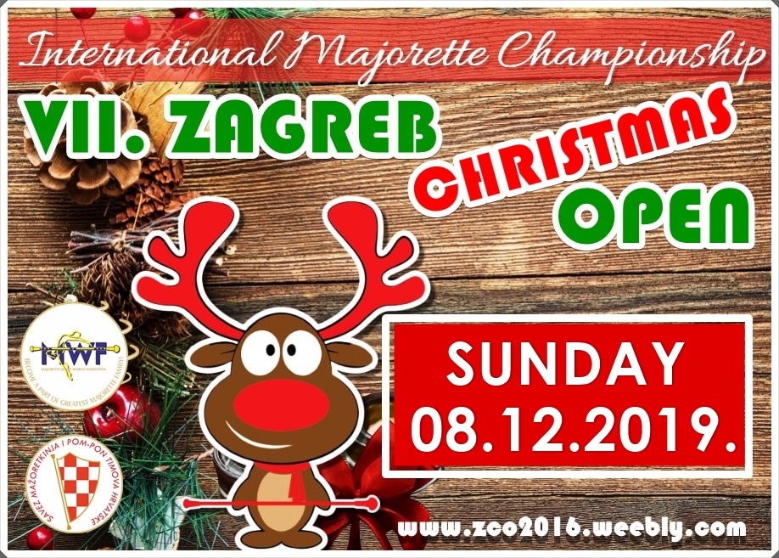

E-mail: zagreb.christmas.open@gmail.com
DEADLINE 15. 11. 2019.
Country: Town: Club,division:

Contact person: Adress: Mob/ E-mail:

SOLO FORMATIONS:

- BATON KIDS:

 | Quote | Person | Competitors last and first name – solo / duo-trio
1 | Solo
2 | Solo
1 | Duo-trio
2 | Duo-trio
1 | Mini form.
2 | Mini form.

- BATON CADETS:

 | Quota | Person | Competitors last and first name – solo / duo-trio
1 | Solo
2 | Solo
1 | duo-trio
2 | duo-trio
1 | Mini
2 | Mini

- BATON JUNIORS:

 | Quota | Person | Competitors last and first name – solo / duo-trio
1 | Solo
2 | Solo
1 | duo-trio
2 | duo-trio
1 | Mini
2 | Mini

- BATON SENIORS:

 | Quota | Person | Competitors last and first name – solo / duo-trio
1 | Solo
2 | Solo
4 | Solo
1 | Solo-two baton
1 | duo-trio
2 | duo-trio
1 | Mini
2 | Mini

- SOLO BATON BO YS:

 | Quota | Person | Competitors last and first name – solo / duo-trio
1 | Solo
2 | Solo
4 | Solo

- POM-POM CADETS:

 | Quota | person | Competitors last and first name – solo / duo-trio
1 | Solo
2 | Solo
1 | duo-trio
2 | duo-trio
1 | Mini
2 | Mini

- POM-POM JUNIORS:

 | Quota | person | Competitors last and first name – solo / duo-trio
1 | Solo
2 | Solo
1 | duo-trio
2 | duo-trio
1 | Mini
2 | Mini

- POM-POM SENIORS:

 | quota | person | Competitors last and first name – solo / duo-trio
1 | Solo
2 | Solo
1 | duo-trio
2 | duo-trio
1 | Mini
2 | Mini

- MIX MINI FORMATIONS-CADETS:

 |  | person
1 | Mini f.
2 | Mini f.

- MIX MINI FORMATIONS -JUNIORS:

 |  | person
1 | Mini f.
2 | Mini f.

- MIX MINI FORMATIONS-SENIORS:

 |  | person
1 | Mini f.
2 | Mini f.

- BATONFLAG MINI FORMATIONS-JUNIORS:

1 | Mini f.
2 | Mini f.

- BATONFLAG MINI FORMATIONS-SENIORS:

 |  | person
1 | Mini f.
2 | Mini f.

- MACE JUNIORS:

 | Quota | Person | Competitors last and first name – solo / duo-trio
1 | Solo
2 | Solo
1 | duo-trio
2 | duo-trio
1 | Mini
2 | Mini

- MACE SENIORS:

 | Quota | Person | Competitors last and first name – solo / duo-trio
1 | Solo
2 | Solo
1 | duo-trio
2 | duo-trio
1 | Mini
2 | Mini

- TWIRLING-cad/jun/sen:

 | Quota | Person | Competitors last and first name – solo / duo-trio
1 | Solo
2 | Solo
1 | duo
2 | duo
1 | Mini
2 | Mini

GROUPS:

- BATON GROUPS ( CAD = cadets, JUN = juniors, SEN = seniors ) ONLY STAGE

Quota | Age category | Group name | Person
1.
2.
1.
2.
1.
2.

- POM-POM GROUPS ( CAD = cadets, JUN = juniors, SEN = seniors ) ONLY STAGE

Quota | Age category | Group name | Person
1.
2.
1.
2.
1.
2.

- CLASIC -BATON ( CAD = cadets, JUN = juniors, SEN = seniors )

Quota | Age category | Group name | Person
1.
2.
3.
4.
5.
6.

- CLASIC –POM-PON (CAD = cadets, JUN = juniors, SEN = seniors )

Quota | Age category | Group name | Person
1.
2.
3.
4.
5.
6.

- MIX GROUPS ( CAD = cadets, JUN = juniors, SEN = seniors )

Quota | Age category | Group name | Person
1.
2.
3.
4.
5.
6.

- BATONFLAG GROUPS:(JUN = juniors, SEN = seniors )

Quota | Age category | Group name | Number person
1.
2.
3.
4.
5.
6.

- MACE GROUPS JUNIORS:

Quota | Age category | Group name | Person
1.
2.
3.

- MACE GROUPS SENIORS:

Quota | Age category | Group name | Person
1.
2.
3.

- DRUMMERS GROUPS JUNIORS:

Quota | Age category | Group name | Person
1.
2.
3.

- DRUMMERS GROUPS SENIORS:

Quota | Age category | Group name | Person
1.
2.
3.

CHRISTMAS CATEGORY:
- BATON-(children, cadets, juniors, seniors)-ONLY STAGE

Qoute | Age category | Group name | Number person
1.
2.
3.
4.
5.
6.

- POM-PON-(children, cadets, juniors, seniors)-ONLY STAGE
Qoute | Age category | Group name | Number person
1.
2.
3.
4.
5.
6.

CATEGORIES

1.BATON GROUPS -only stage choreography for teams
- time minimally 2:30 maximally 3:00 minute

2.POM-POM GROUPS -only stage choreography for teams
-time minimally 2:30 maximally 3:00 minute

3.CLASSIC BATON- only stage choreography for teams
- time minimally 2:30 maximally 3:00 minute

4.CLASSIC POM-PON- only stage choreography for teams
- time minimally 2:30 maximally 3:00 minute

5.MIX -groups (8-25) –time 2,30-3,00 min.-only stage choreograph

6. BATONFLAG-mini formations 4-7 girls/-time 1,15-1,30 min.

7. BATONFLAG-GROUPS 8-25 girls/ time 2,30-3,00 min.-only stage choreograph

8. MACE-solo, duo-trio, mini formations /-time 1,15-1,30 min.

-mini formations 4-7 girls/-time 1,15-1,30 min.

9. MACE-groups 8-25 girls/-time 2,30-03,00 min.

-mini formations 4-7 girls/-time 1,15-1,30 min.

10. MIX- groups- 8 -25 girls/2,30-3,00 min.-only stage choreograph
- BAT+POM
- BAT+FLAG
- POM+FLAG

11. DRUMMERS-mini formations /-time 1,15-1,30 min.

-mini formations 4-7 girls/-time 1,15-1,30 min.

12.-DRUMMERS –groups – 8 -25 girls / time 2,30-3,00 min.-only stage choreograph

-mini formations 4-7 girls/-time 1,15-1,30 min.

13.CHRISTMAS CATEGORY-GROUPS baton/pom-pon/cadets juniors, seniors-ONLY STAGE CHOREOGRAPHY!
-Christmas music, Christmas costumes-SPECIAL AWARDS!

14. TWIRLING-solo, duo, mini formations /-time 1,15-1,30 min.
CADETS/ JUNIORS/ SENIORS

SOLO FORMATIONS
-solo, solo two baton –only seniors, duo-trio, mini formations:

- Mini formations baton, 4-7 person
- Mini formations pom-pon, 4-7 person
- Mini formations mix, 4-7 person
- Mini formations batonflag, 4-7 person
- Mini formation drumers, 4-7 person

GROUPS:
-8 -25 members
- BATON, POM-PON, MIX, BATONFLAG, CLASSIC BATON. CLASSIC POM-PON
- CHRISTMAS CATEGORY /baton, pom-pon/
- ALL GROUPS-ONLY STAGE CHOREOGRAPHY!

SOLO FORMATIONS

- solo
- duo or trio
- mini formations -4 – 7 persons

AGE CATEGORIES
1. children-age of 4-6 years
2. cadets – age of 6 – 11 years
3. juniors – age of 12 – 14 years
4. seniors – age of 15 years and more

STAGE:
- stage 12 x 12 meters / minimum 10 x 10 m
- time-groups: minimally 2.30 , maximally 3.00 minutes (without the time for coming and leaving )
- time-solo formations: minimally 1,15 , maximally 1,30 minutes

